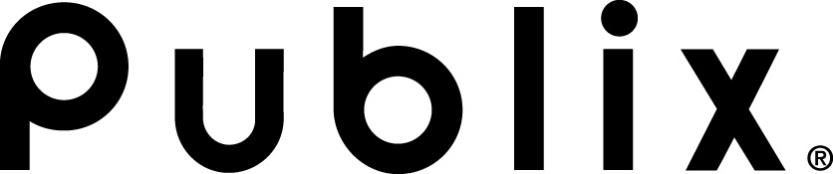

To
Suppliers
From
Norman Badger, Brad Oliver
cc
Dave Bornmann
Date
October 9, 2023
Subject
2024 Corporate Sales Event & Co-Op Changes

Purpose
Starting in 2024, we are changing the external advertising component of our weekly ad Sales Event & Co-op programs. This change will require our selected suppliers to work with approved 3rd party marketing agencies to execute a custom digital media campaign. The digital campaign creative will highlight key product attributes (versus our current practice of including Publix event theme content) and encourage more consumers to buy the participating item at Publix. All other sales event and co-op program components such as in-store advertising, owned media (P.com and Publix app), displays, weekly ad flex areas, etc. will be unchanged. Publix Marketing will continue to develop the event themes and these supporting pieces. The changes include:
- Requiring suppliers to work directly with approved 3rd party marketing agencies to develop and execute external paid media (social media, digital ads, etc.). Participating suppliers will be given an updated Publix style guide to help ensure that the creative content for the digital messages will be acceptable to Publix. For each event, suppliers will be expected to spend a minimum amount on external advertising as outlined in our updated sell sheets.
- Eliminating the need for suppliers to pay Publix for Sales Event and Co-Op advertising. Suppliers will pay the 3rd party marketing agencies directly.

continued on next page

Benefits
By providing our suppliers with more control and flexibility over the external advertising component creates efficiencies that will improve marketing effectiveness for both Publix and our suppliers. Benefits include:
- Streamlining our supplier’s processes by allowing them to work directly with the approved 3rd party marketing agencies including payment directly to the agency.
- Most importantly, the external digital messaging will be more effective. The external digital messages will focus on key consumer product attributes (versus Publix event themes) that will achieve better customer search results. This will result in greater participating item views and clicks leading consumers to purchase the participating items at Publix. Below is a comparison of Publix theme-based creative (on the left) and product attribute focused content (on the right). For example, more customers may discover the new Hellmann’s spicy spread after searching for spicy flavors.

Current | Future (MOCKUP FOR EXAMPLE ONLY)
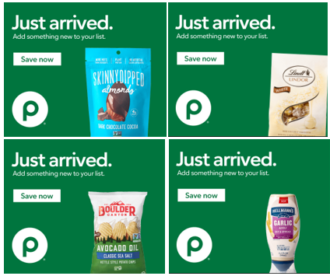  Multiple brands in single ad; general targeting | 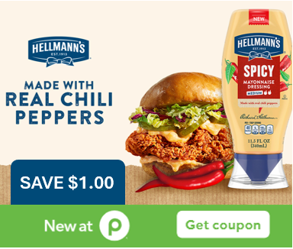  Brands will promote using their own creative assets; custom targeting

continued on next page

Additional details
The following additional details further clarify the impacts of these changes:
- We will continue to set the annual calendar of approved promotions, define participation costs, and maintain the process of supplier and item selections.
- Program sell sheets will continue to be posted to Publix.biz quarterly and you will continue to submit interest to your category team.
- Your category team will remain your point of contact. Once selected, your category team will provide you with an updated Publix style guide along with direction on how to engage and work with the 3rd party marketing agency.
- Publix Marketing will continue to provide in-store signage and owned media (email and advertising on p.com) at no additional charge to suppliers.
- Aprons will no longer solicit supplier inclusion in any recipe activity. This will eliminate the Holiday Co-Op programs and the paid advertising as part of Cooking School Online.

Next steps and questions
More detailed communications for Q1 programs can be found on Publix.biz. Please contact your category team with any questions.

end of document

